Activity | Data Type
Number of beatings from Wife | Discrete
Results of rolling a dice | Discrete
Weight of a person | Continuous
Weight of Gold | Continuous
Distance between two places | Continuous
Length of a leaf | Continuous
Dog's weight | Continuous
Blue Color | Discrete
Number of kids | Discrete
Number of tickets in Indian railways | Discrete
Number of times married | Discrete
Gender (Male or Female) | Discrete
Q1) Identify the Data type for the Following:

Q2) Identify the Data types, which were among the following
Nominal, Ordinal, Interval, Ratio.
Data | Data Type
Gender | Nominal
High School Class Ranking | Ordinal
Celsius Temperature | Interval
Weight | Interval
Hair Color | Nominal
Socioeconomic Status | Ordinal
Fahrenheit Temperature | Interval
Height | Ratio
Type of living accommodation | Ordinal
Level of Agreement | Ordinal
IQ(Intelligence Scale) | Ratio
Sales Figures | Ratio
Blood Group | Nominal
Time Of Day | Interval
Time on a Clock with Hands | Interval
Number of Children | Nominal
Religious Preference | Nominal
Barometer Pressure | Interval
SAT Scores | Interval
Years of Education | Ratio

Q3) Three Coins are tossed, find the probability that two heads and one tail are obtained?
Total no of events: {hhh,hht,hth,htt,thh,ttt,tth,tht} =8
Ans:3/8

Q4) Two Dice are rolled, find the probability that sum is
- Equal to 1-------
Ans)0/12
- Less than or equal to 4------
Ans){(1,1),(1,2),(1,3),(2,1)(3,1)(2,2)}=6/36=1/6
- Sum is divisible by 2 and 3
Ans){(1,1),(1,2),(1,3),(1,4)(1,5),(1,6)-2
(2,1),(2,2),(2,3),(2,4),(2,5),(2,6)-2
(3,1),(3,2),(3,3),(3,4),(3,5),(3,6)-1
(4,1),(4,2),(4,3),(4,4),(4,5),(4,6)-1
(5,1),(5,2),(5,3),(5,4),(5,5),(5,6)-1
(6,1),(6,2),(6,3),(6,4),(6,5),(6,6)}
6/36=1/6

Q5) A bag contains 2 red, 3 green and 2 blue balls. Two balls are drawn at random. What is the probability that none of the balls drawn is blue?

Ans) total number of events= ${nC}_{r}$=${7C}_{2}$=$\frac{7!}{2!*5!}$=21
Interested events=${5C}_{2}$=$\frac{5!}{2!*3!}$=10
Probability that none of the balls is blue =10/21=0.47

Q6) Calculate the Expected number of candies for a randomly selected child
Below are the probabilities of count of candies for children (ignoring the nature of the child-Generalized view)
CHILD | Candies count | Probability
A | 1 | 0.015
B | 4 | 0.20
C | 3 | 0.65
D | 5 | 0.005
E | 6 | 0.01
F | 2 | 0.120
Child A – probability of having 1 candy = 0.015.
Child B – probability of having 4 candies = 0.20
Total :21 candies
EV:1*.015+4*.2+3*.65+5*.005+6*.01+2*.12=3.09

Q7) Calculate Mean, Median, Mode, Variance, Standard Deviation, Range & comment about the values / draw inferences, for the given dataset
1)Find Mean, Median, Mode, Variance, Standard Deviation, and Range and also Comment about the values/ Draw some inferences.
Use Q7.csv file

- For Points,Score,Weigh>
- MEAN
- mean(q7$Points)
- [1] 3.596563
- > mean(q7$Weigh)
- [1] 17.84875
- > mean(q7$Points)
- [1] 3.596563
- MEDIAN
- median(q7$Points)
- [1] 3.695
- > median(q7$Score)
- [1] 3.325
- > median(q7$Weigh)
- [1] 17.71

MODE
getMode(q7$Points)
[1] 3.92
> getMode(q7$Score)
[1] 3.44
> getMode(q7$Weigh)
[1] 17.02

VARIANCE

> var(q7$Points)
[1] 0.2858814
> var(q7$Score)
[1] 0.957379
> var(q7$Weigh)
[1] 3.193166

STD Deviation

> sd(q7$Points)
[1] 0.5346787
sd(q7$Score)
0.9784574
sd(q7$Weigh)
1.786943

RANGE

> range(q7$Points)
[1] 2.76 -4.93
> range(q7$Score)
[1] 1.513 -5.424
> range(q7$Weigh)
[1] 14.5 -22.9

Inference: As the range between the three columns is less we can say that all the data points in this lies within a smaller range and we can make the same conclusion as the std deviation value is also less, only for the weight column the SD value is more than 1.Here there is no outliers.

Q8) Calculate Expected Value for the problem below
- The weights (X) of patients at a clinic (in pounds), are
108, 110, 123, 134, 135, 145, 167, 187, 199
Assume one of the patients is chosen at random. What is the Expected Value of the Weight of that patient?
Ans: Sum of all the weights/N=145.3

Q9) Calculate Skewness, Kurtosis & draw inferences on the following data
Cars speed and distance
Use Q9_a.csv
library(e1071)
> skewness(q9$speed)
[1] -0.1105533
> skewness(q9$dist)
[1] 0.7591268
> kurtosis(q9$speed)
[1] -0.6730924
> kurtosis(q9$dist)
[1] 0.1193971

Inference: Speed is negatively skewed which indicates the distribution is towards left and distance is positive which indicates the distribution is towards right
Kurtosis is negative for speed which means the distribution has lighter tails and for distance the kurtosis is positive which means the distribution has heavier tails

SP and Weight(WT)
> skewness(q9b$SP)
[1] 1.552258
> skewness(q9b$WT)
[1] -0.5921721
> kurtosis(q9b$SP)
[1] 2.583072
> kurtosis(q9b$WT)
[1] 0.7257402

Q10) Draw inferences about the following boxplot & histogram

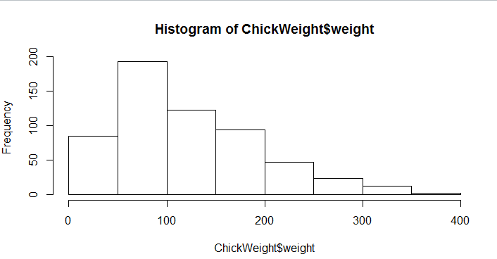
Inference: Distribution is positively skewed and most of the values lies between 50 to 100
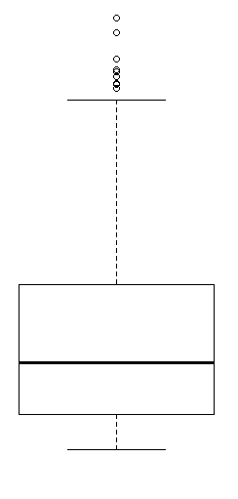
Inference: Outliers are visible from the boxplot and Q3 quartile shows more values

Q11) Suppose we want to estimate the average weight of an adult male in Mexico. We draw a random sample of 2,000 men from a population of 3,000,000 men and weigh them. We find that the average person in our sample weighs 200 pounds, and the standard deviation of the sample is 30 pounds. Calculate 94%,98%,96% confidence interval?
n=2000
$\overline{X}$= 200
s= 30
CI=$\overline{X}$ $±$ Z$\frac{s}{\sqrt{n}}$
Ans: qnorm(.94)
> 200-1.55*(30/sqrt(2000))
[1] 198.9602
> 200+1.55*(30/sqrt(2000))
[1] 201.0398
94%-( 198.9602– 201.0398)

> 200-1.75*(30/sqrt(2000))
[1] 198.8261
> 200+1.75*(30/sqrt(2000))
[1] 201.1739
96%-(198.8261-201.1739)

> 200-2.05*(30/sqrt(2000))
[1] 198.6248
> 200+2.05*(30/sqrt(2000))
[1] 201.3752
99%-198.6248-201.3752

Q12) Below are the scores obtained by a student in tests
34,36,36,38,38,39,39,40,40,41,41,41,41,42,42,45,49,56
- Find mean, median, variance, standard deviation.
- What can we say about the student marks?
Mean:41
Median:40.5
Variance:25.5
SD:5.05
2)mean>median . This indicates the distribution is rightly skewed.
Q13) What is the nature of skewness when mean, median of data are equal?
Ans: This indicates the distribution is normally distributed. Symmetric

Q14) What is the nature of skewness when mean > median ?
Ans: Right Skewed
Q15) What is the nature of skewness when median > mean?
Ans: Left Skewed
Q16) What does positive kurtosis value indicates for a data ?
Ans: The curve is peak and has less variation.
Q17) What does negative kurtosis value indicates for a data?
Ans: The curve is flat and more variation.
Q18) Answer the below questions using the below boxplot visualization.
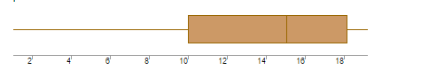
What can we say about the distribution of the data?
Ans: Not normally distributed
What is nature of skewness of the data?
Ans: Left skewed
What will be the IQR of the data (approximately)?
Ans: IQR=18-10=8

Q19) Comment on the below Boxplot visualizations?
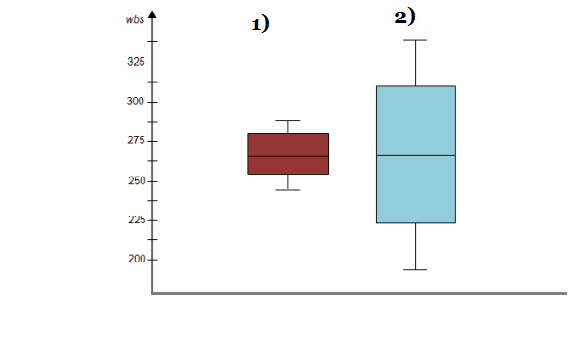
Draw an Inference from the distribution of data for Boxplot 1 with respect Boxplot 2.
Ans: Range of values of Boxplot 1 is less than Boxplot 2.The average of both boxplot 1 and boxplot 2 is almost similar. Both boxplot looks normally distributed.

Q 20) Calculate probability from the given dataset for the below cases

Data _set: Cars.csv
Calculate the probability of MPG of Cars for the below cases.
MPG <- Cars$MPG
  - P(MPG>38)
Ans: > mean(MPG): 34.42208
sd(MPG): 9.131445
1-pnorm(38,34.42208,9.131445): 0.3475941

  - P(MPG<40)
Ans:mean(MPG): 34.42208
sd(MPG): 9.131445
pnorm(40,34.42208,9.131445): . 7293497

c. P (20<MPG<50)
pnorm(50,34.42,9.13)-pnorm(20,34.42,9.13)
[1] 0.8989178

Q 21) Check whether the data follows normal distribution
- Check whether the MPG of Cars follows Normal Distribution
Dataset: Cars.csv
qqnorm(car$MPG)
The plot is normally distributed .
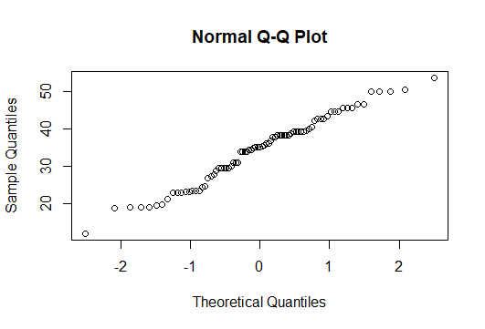
- Check Whether the Adipose Tissue (AT) and Waist Circumference(Waist) from wc-at data set follows Normal Distribution
Dataset: wc-at.csv
Ans: Waist and AT does not follow normal distribution based on the qqplot and shaipro test.
WAIST
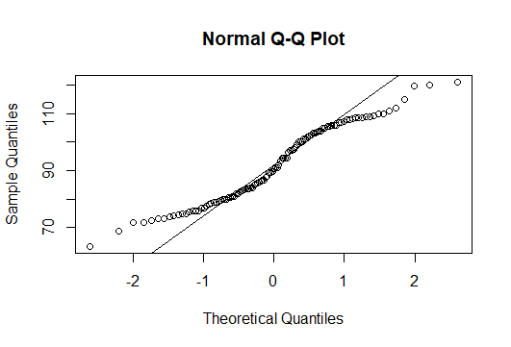
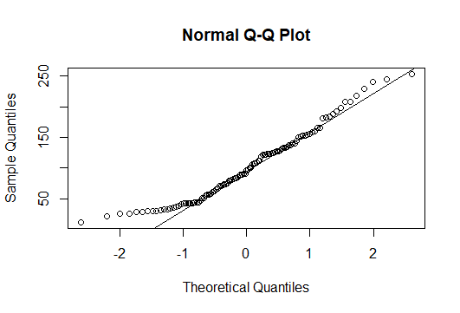
shapiro.test(waist$Waist):p value is .0011 which less than .05 and reject null hypothesis and the plot does not follow normal distribution.
shapiro.test(waist$AT):p value is .0006 which less than .05 and reject null hypothesis and the plot does not follow normal distribution.

Q 22) Calculate the Z scores of 90% confidence interval,94% confidence interval, 60% confidence interval
Ans: 90% (qnorm(.05,lower.tail = F): 1.644854)
94%(qnorm(.03,lower.tail = F): 1.880794)
60%(qnorm(.2,lower.tail = F): 0.8416212)
>

Q 23) Calculate the t scores of 95% confidence interval, 96% confidence interval, 99% confidence interval for sample size of 25
95% / qt(p =.025,df = 24 ,lower.tail = F):- 2.063899
96%/ qt(p =.02,df = 24 ,lower.tail = F):-2.171545
99%/ qt(p =.005,df = 24 ,lower.tail = F):- 2.79694

Q 24) A Government company claims that an average light bulb lasts 270 days. A researcher randomly selects 18 bulbs for testing. The sampled bulbs last an average of 260 days, with a standard deviation of 90 days. If the CEO's claim were true, what is the probability that 18 randomly selected bulbs would have an average life of no more than 260 days
Hint:
rcode pt(tscore,df)
df degrees of freedom
Ans: µ=270, $\overline{x}$=260, SD=90, n=18, df=n-1=18-1= 17
$\frac{\overline{x}-µ}{s/\sqrt{n}}$ = $\frac{260-270}{90/\sqrt{18}}$ = -10/21.23= -0.47
pt(-.47,17,lower.tail = F) =0.3221639, Probability:32%

Null hypothesis: Average bulb last more than 260 days
Alternate hypothesis: Average bulb last less than or equal to 260 days
As the p value is high we accept null hypothesis that the average bulb last more than 260 days

